**Reference:** [**https://trailhead.salesforce.com/content/learn/projects/build-your-personal-portfolio-on-salesforce/add-pages-to-your-site?trailmix_creator_id=trailblazerconnect&trailmix_slug=salesforce-fundamentals-week-1**](https://trailhead.salesforce.com/content/learn/projects/build-your-personal-portfolio-on-salesforce/add-pages-to-your-site?trailmix_creator_id=trailblazerconnect&trailmix_slug=salesforce-fundamentals-week-1)

**Activate Digital Experience**

1. Enable Digital Experience

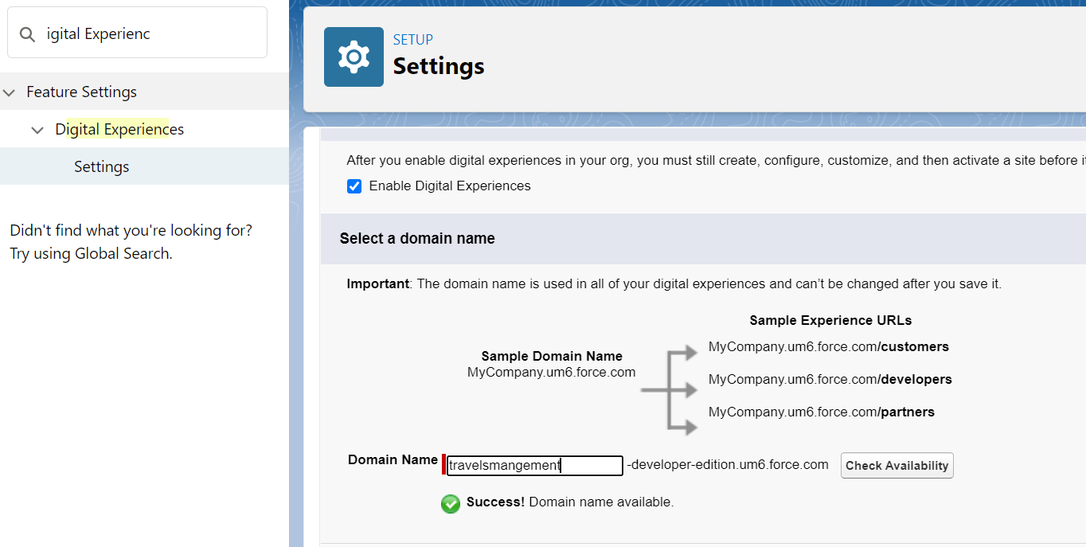

1. Verify domain availability
2. Create New Site (**Maximum number of sites (including active, inactive, and preview): 100**)

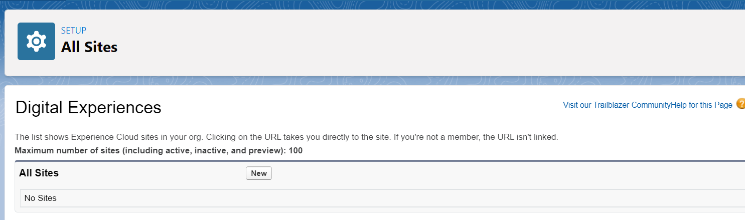

1. Select Template.

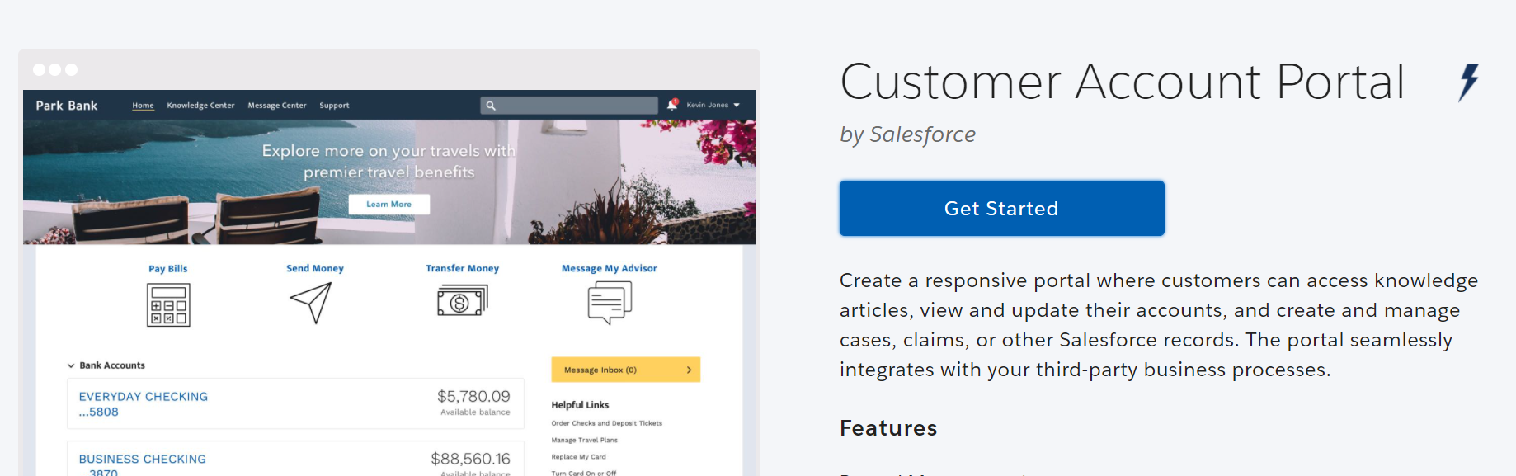

1. Provide a Name and URL extension

**Customize the Page**

1. Customize the website by using the settings in the builder.

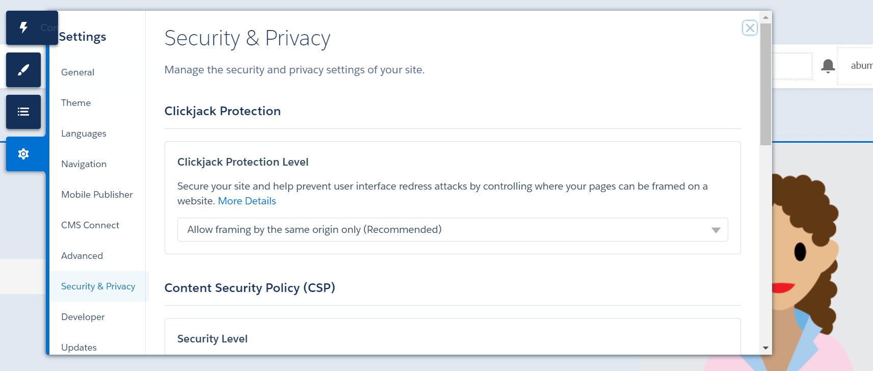

**Create Pages**

1. Click on the settings wheel at the top of the screen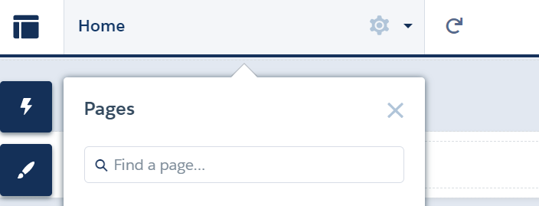

Select new page at the bottom of the menu.

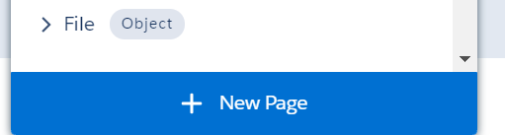

**Create Navigation**

1. Navigate back to the pages and select home.
2. In home select the Menu tile.

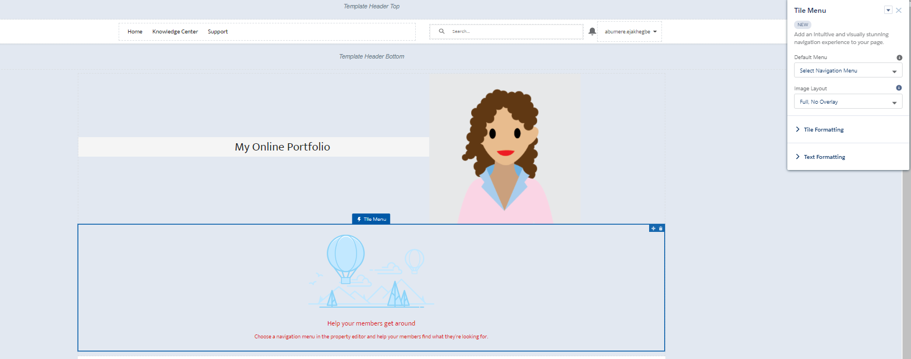

1. Select default Menu and Edit Default Navigation

